# LAB-3

## Topic covered:-

## CSS-Learning:-

* Introduction
* Syntax
* Selectors
* Ways to Insert CSS
* Comments
* Colors
* Background
* Borders
* Margin
* Padding
* Height/Width
* Box-Model
* Outline
* Text

**1-INTRODUCTION:-**

CSS is the language we use to style a Web page

## **What is CSS?**

* CSS stands for Cascading Style Sheets
* CSS describes how HTML elements are to be displayed on screen, paper, or in other media
* CSS saves a lot of work. It can control the layout of multiple web pages all at once
* External stylesheets are stored in CSS files

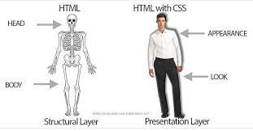Below picture give you an idea of how css changes the HTML page:-

These are just examples.

## **CSS Solved a Big Problem**

HTML was NEVER intended to contain tags for formatting a web page!

HTML was created to describe the content of a web page, like:

<h1>This is a heading</h1>

<p>This is a paragraph.</p>

When tags like <font>, and color attributes were added to the HTML 3.2 specification, it started a nightmare for web developers. Development of large websites, where fonts and color information were added to every single page, became a long and expensive process.

To solve this problem, the World Wide Web Consortium (W3C) created CSS.

CSS removed the style formatting from the HTML page!

## **CSS Saves a Lot of Work!**

The style definitions are normally saved in external .css files.

With an external stylesheet file, you can change the look of an entire website by changing just one file!

**2-CSS-Syntax:-**

A CSS rule consists of a selector and a declaration block.

1. CSS Rule: A CSS rule consists of a selector and one or more declarations enclosed in curly braces `{}`. It defines how a specific element or group of elements should be styled.

2. Selector: A selector is used to target HTML elements that you want to style. It can be a tag name, class, ID, attribute, or a combination of these. Selectors determine which elements the CSS rule will be applied to.

3. Declarations: Declarations are made up of one or more property-value pairs separated by semicolons. They define the visual properties or characteristics of the selected elements.

4. Property: A property represents a specific visual aspect of an element that you want to modify, such as `color`, `font-size`, `background-image`, etc. Each property has a corresponding value.

5. Value: The value specifies the desired setting for the associated property. It can be a color, size, keyword, URL, or any valid CSS value.

There is an Example given below…

Here's an example of basic CSS syntax:

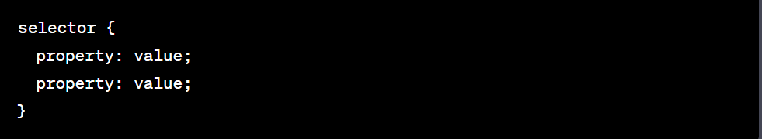

In this example:

- The `selector` represents the HTML element(s) you want to style. It can be a tag name, class, ID, or other selectors.

- Within the curly braces `{}`, you define one or more `property: value` pairs.

- Each `property’represents a visual characteristic you want to modify, such as `color`, `font-size`, `background-color`, etc.

- The `value’specifies the desired value for the corresponding property. For example, `red` for `color` or `center` for `text In center `.

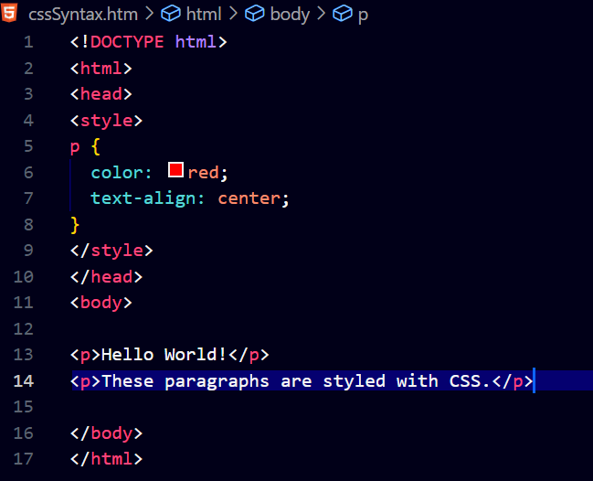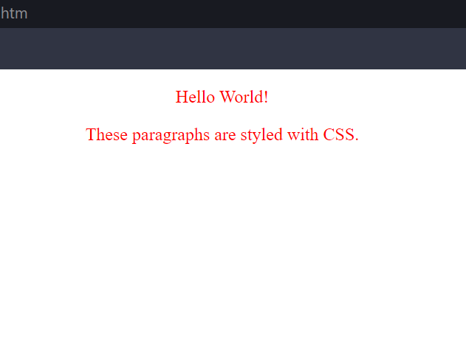Code:- Web page display:-

In our code

* p is selector
* color and text-align are property
* red and center are value

## **3-CSS Selectors**

CSS selectors are used to "find" (or select) the HTML elements you want to style.

We can divide CSS selectors into five categories:

* Simple selectors (select elements based on name, id, class)
* [Combinator selectors](https://www.w3schools.com/css/css_combinators.asp) (select elements based on a specific relationship between them)
* [Pseudo-class selectors](https://www.w3schools.com/css/css_pseudo_classes.asp) (select elements based on a certain state)
* [Pseudo-elements selectors](https://www.w3schools.com/css/css_pseudo_elements.asp) (select and style a part of an element)
* [Attribute selectors](https://www.w3schools.com/css/css_attribute_selectors.asp) (select elements based on an attribute or attribute value)

We will discuss about most basic CSS selectors:-

(A)Element Selector:-

The element selector selects HTML elements based on the element name.

(B)Id Selector:-

The id selector uses the id attribute of an HTML element to select a specific element.

The id of an element is unique within a page, so the id selector is used to select one unique element!

To select an element with a specific id, write a hash (#) character, followed by the id of the element.

(C)Class Selector:-

The class selector selects HTML elements with a specific class attribute.

To select elements with a specific class, write a period (.) character, followed by the class name

(D)Universal Selector:-

The universal selector (*) selects all HTML elements on the page

(E)Grouping Selector:-

The grouping selector selects all the HTML elements with the same style definitions.

**4-How to Insert CSS**

## **Three Ways to Insert CSS**

There are three ways of inserting a style sheet:

External CSS

Internal CSS

Inline CSS

## **Inline CSS**

## An inline style may be used to apply a unique style for a single element.

To use inline styles, add the style attribute to the relevant element. The style attribute can contain any CSS property.

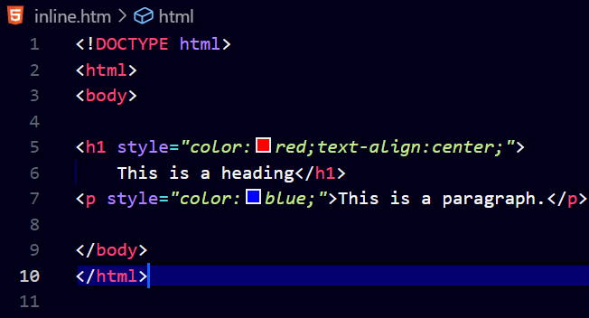Code:-

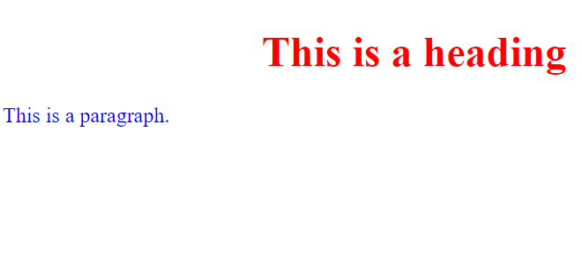Web page Display:-

## **Internal CSS**

An internal style sheet may be used if one single HTML page has a unique style.

The internal style is defined inside the <style> element, inside the head section.

Code:-

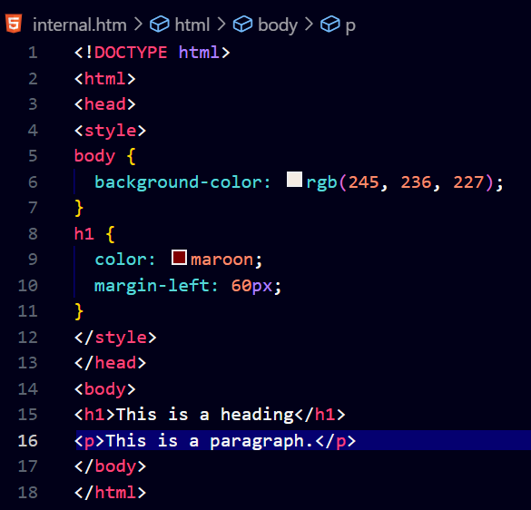

Web Page Display:-

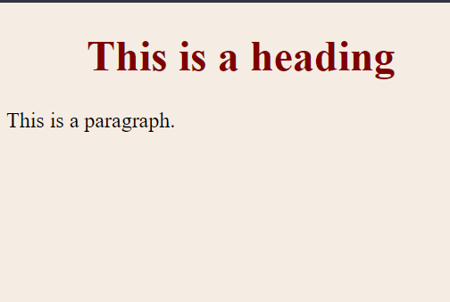

## **External CSS**

With an external style sheet, you can change the look of an entire website by changing just one file!

Each HTML page must include a reference to the external style sheet file inside the <link> element, inside the head section.

An external style sheet can be written in any text editor, and must be saved with a .css extension.

The external .css file should not contain any HTML tags.

**Code:-**

**(i)HTML s**

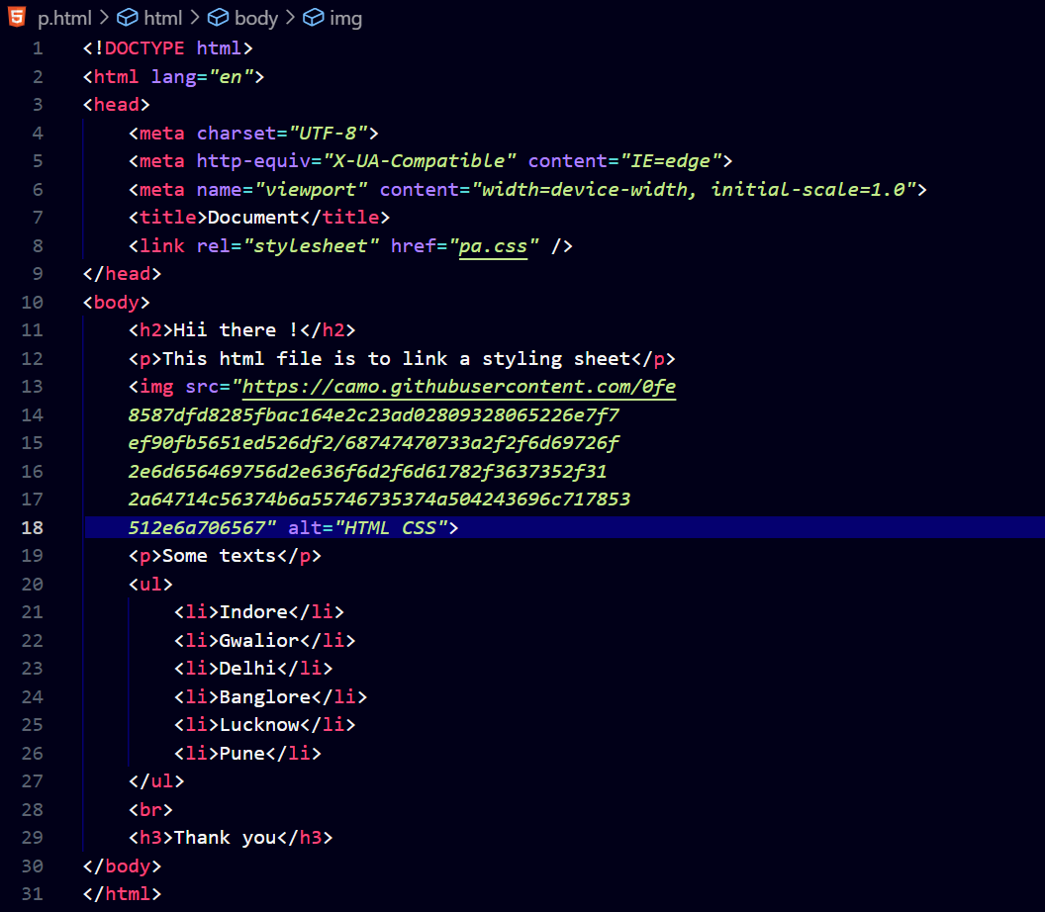

**Code:-**

**(ii)CSS Styling Sheet**

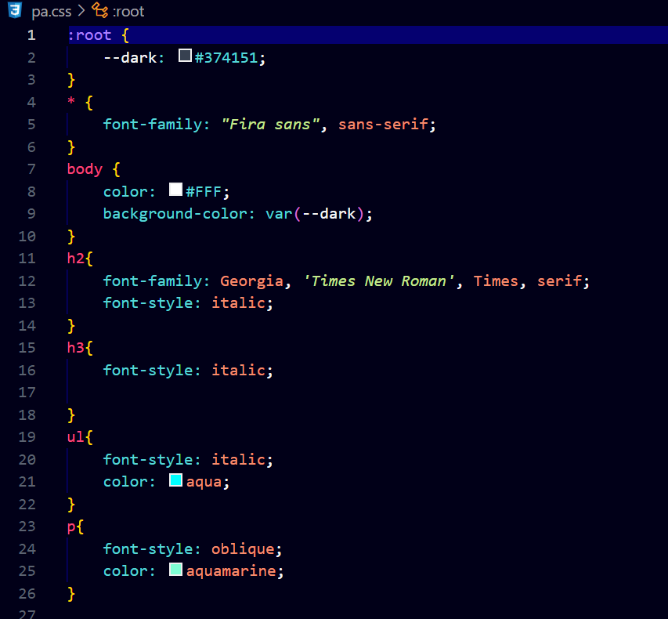

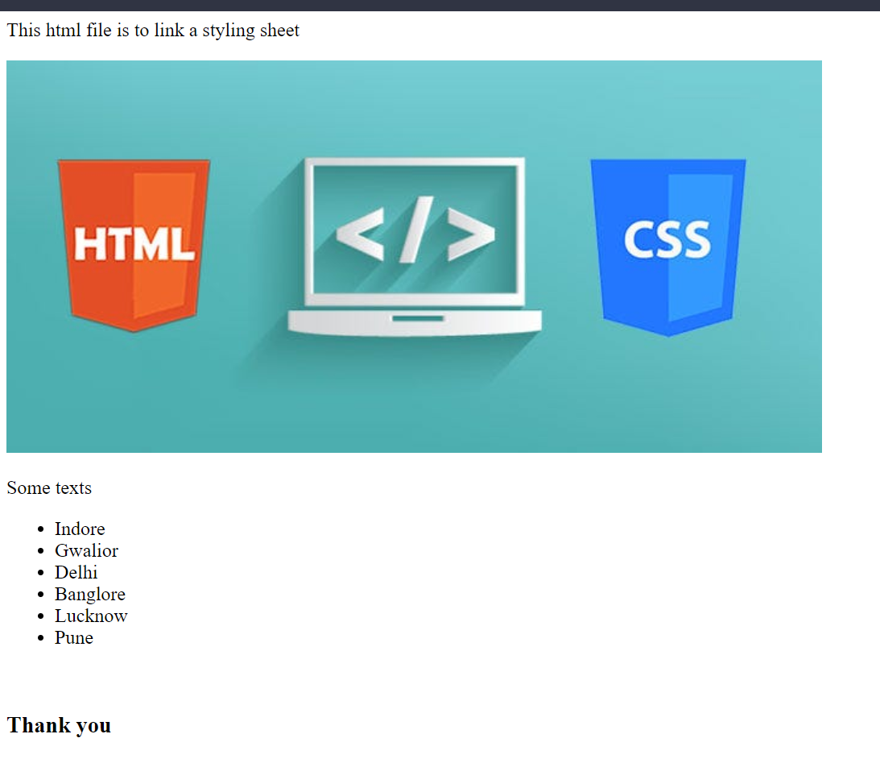**Web page Display:-**

**5-Comments in CSS:-**

**Comments in CSS are used to include explanatory or informative notes within the code. They serve as non-executable text and are ignored by the browser when rendering the webpage. Comments are helpful for documenting the CSS code, providing context, and leaving reminders for yourself or other developers.**

Comments are used to explain the code, and may help when you edit the source code at a later date.

Comments are ignored by browsers.

A CSS comment is placed inside the <style> element, and starts with /* and ends with */

**- These comments are often used to provide documentation or temporarily disable blocks of code.**

**Using comments in CSS is a good practice for maintaining clean, readable, and well-documented code. They play a vital role in facilitating code understanding, collaboration, and future maintenance of CSS stylesheets.**

6-Colors in CSS:-

# **CSS Colors**

Colors are specified using predefined color names, or RGB, HEX, HSL, RGBA, HSLA values.

## **CSS Color Names**

In CSS, a color can be specified by using a predefined color name:

Tomato

Orange

DodgerBlue

MediumSeaGreen

Gray

SlateBlue

Violet

## **CSS Background Color**

You can set the background color for HTML elements:

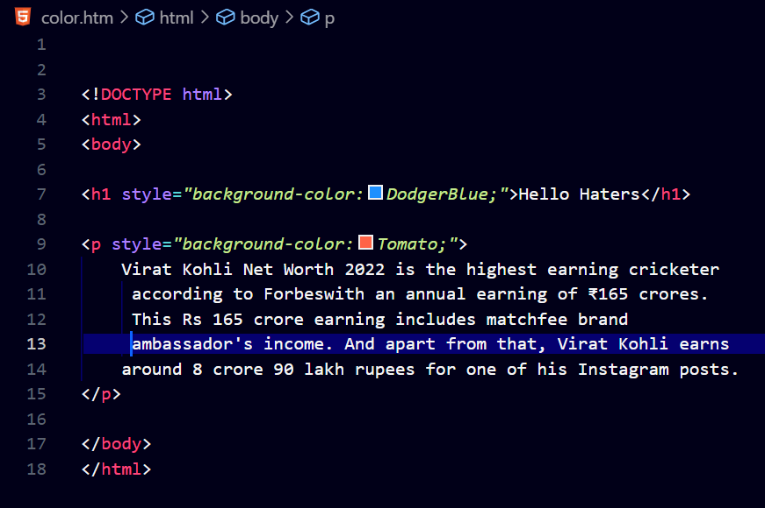Code:-

Web page Display:-

